UK DECLARATION OF CONFORMITY No 13082024
- PPE (product number): MBK – Mamba Med Nitrile Disposable Gloves

- Name and address of manufacturer:
Black Mamba Gloves
6865 Shiloh Road East
Alpharetta
GA 30005
USA

Product description: Black Mamba Black Snakeskin Nitrile Disposable Gloves
Product code(s): MBK90, MBK100, MBK110, MBk120, MBK130 & MBK140
Sizes: XS S, M, L, XL & XXL

- Name & address of authorised UK representative:
Fortress Distribution Ltd
Scorpio House, Rockingham Drive,
Linford Wood,
Milton Keynes
MK14 6LY
UK

- This declaration of conformity is issued under the sole responsibility of the importer:
Fortress Distribution Ltd

- Objects of the declaration:
Mamba Med Nitrile Disposable Gloves
Product code(s): BX-MBK-XS, BX-MBK-S, BX-MBK-M, BX-MBK-L, BX-MBK-XL & BX-MBK-XXL
Sizes: XS, S, M, L, XL & XXL

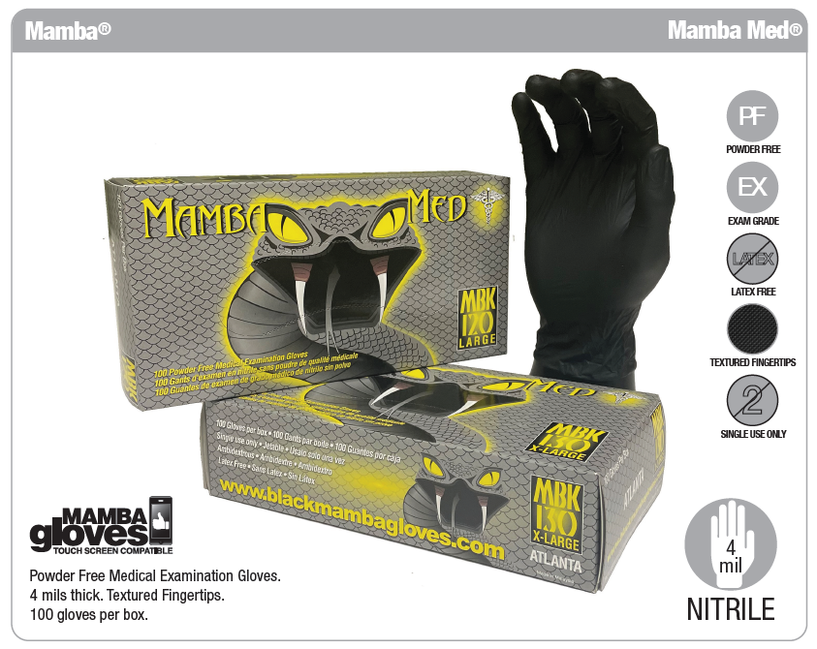

- The above-named product conforms with the following legislation:
PPE Regulation – Module B of Regulation 2016/425 on personal protective equipment, as amended to apply in GB.

This product group has been shown to satisfy the applicable essential health and safety requirements as a Category III product.

- The above-named product conforms with the following Standards:
Standard No. | Description | Certificate No. | Date of Issue | Date of Expiry
EN ISO 374-1: 2016 / Type C  40% Sodium Hydroxide Level 6  37% Formaldehyde Level 6 | Terminology and performance requirements for chemical risks | AB0321/18859-01/E01-01 | 13/08/2024 | 07/10/2026
EN ISO 374-5: 2016  Protection against bacteria & fungi – PASS  Protection against viruses – N/A | Terminology and performance requirements for micro-organisms risks | AB0321/18859-01/E01-01 | 13/08/2024 | 07/10/2026
EN 420:2003+A1:2009 | Sizing and dexterity | AB0321/18859-01/E01-01 | 13/08/2024 | 07/10/2026

- EU type-examinations (Module B) were carried out and certified by Notified Body:
Satra Technology Centre Ltd
Wyndam Way, Telford way,
Kettering, Northamptonshire
NN16 8SD
UK
Notified Body Reference: 0321

- This PPE is subject to the conformity assessment procedure to type based on quality assurance of the production process (Module D) under surveillance of notified body:
SGS United Kingdom Limited
Rossmore Business Park, Inway Ward,
Ellesmere Port,
CH65 3EN, UK
Notified Body Reference: AB 120
Signed for and on behalf of:
Black Mamba Gloves
6865 Shiloh Road East
Alpharetta
GA 30005, USA

Signature: 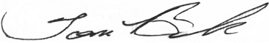
Name: Tom Brooks, Director of Dealer Development
Date: 13th April 2024

